Project SEARCH
Benefits
Internship training experiences Competitive, transferable,
2
1
and marketable job skills Increased independence, confidence and self-esteem
3

Individualized coaching on the job and feedback daily
4

Building personal and professional relationships
5

Participation in a curriculum focused on soft skills required to maintain employment in addition to financial literacy, health
and more
6

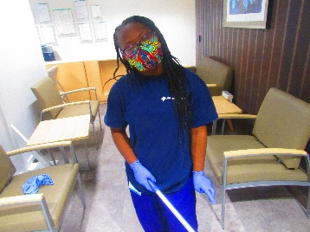

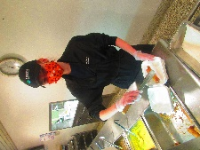

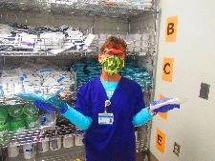

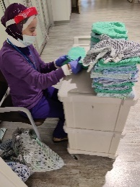

For more information, contact:
Kristina Bokulich, Special Education Supervisor 874-6050

Amanda Habursky, Transition Coordinator 874-6061

Karen DiGangi, OVR 871-4551

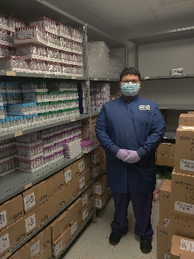
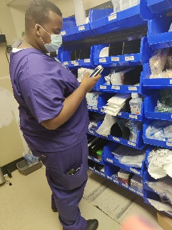

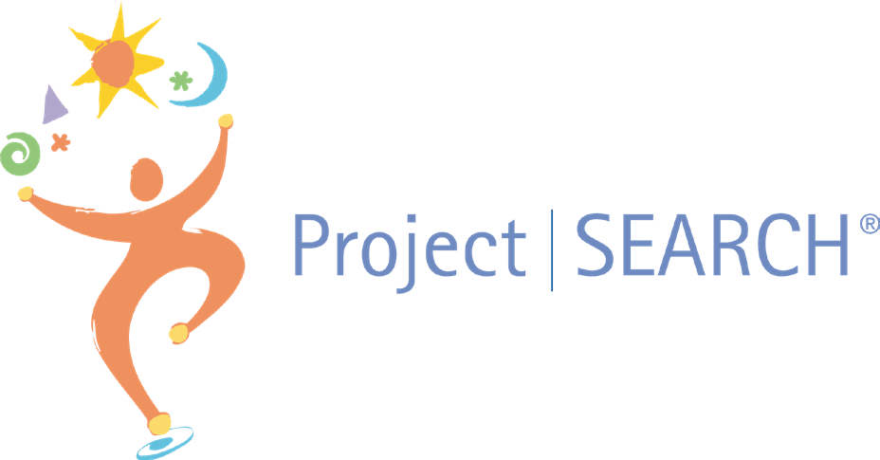

A unique, school-to-work transition program for students with learning disabilities and autism

Project SEARCH is a one-year internshp program for students with disabilities.
What is Project SEARCH?
It is targeted for students whose goal is competitive employment in the community.
Opportunities are very diverse and include health care, universities, manufacturing facilities and more.
Students participate in three paid internships to explore a variety of career paths.
Each student works with a team that includes his or her family, an instructor, job coaches and
host business mentors to
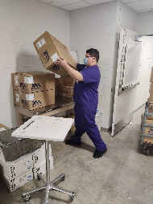
create an employment goal and to support
the student during the transition from school to work.

“I have become more independent since
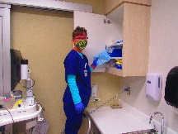
I started Project SEARCH.”
2016/2017 Intern
The Project SEARCH Philosophy:

“People with disabilities have the right to choose a path toward education and employment.
However, while the freedom of choice is given, the right to work is earned. Earning the right to work is dependent upon the student’s preparation.”
Stephen Simon, ADA Quarterly Fall 1998

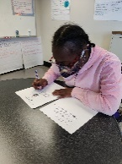
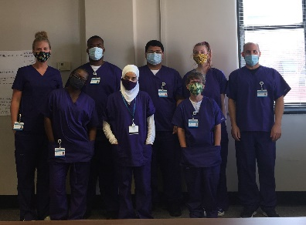

A typical day includes:
9:00 to 11:00: Classroom instruction in employability and independent living skills.

11:00 to 2:00: Paid internship at a facility or department
2:00 to 3:00 Classroom time to discuss and debrief
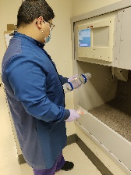
Interns have lunch with colleagues during their workday and participate in meetings and social events.

Outcome goal is full time, paid employment
Core Components of
Project SEARCH

True co-production across partners is essential

Business-led program requiring
1
2
3

total immersion in the workplace

Focus on serving young adults with significant learning disabilities who will need to receive follow-on services to retain employment
4

Partners must provide a

consistent on-site staff team
5

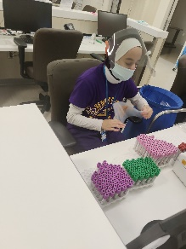
Each site has a licensing agreement with Project SEARCH
6

